Pup Inflation Analysis

According to analysts at WeRateDogs, dog ratings have plateaued. The twitter account that reposts pictures of dogs with ratings from around the world came to that conclusion. This was done by scraping data with ratings less than 26 and analyzing them.

The following graph displays the ratings of dogs from January of 2016 to June of 2019:

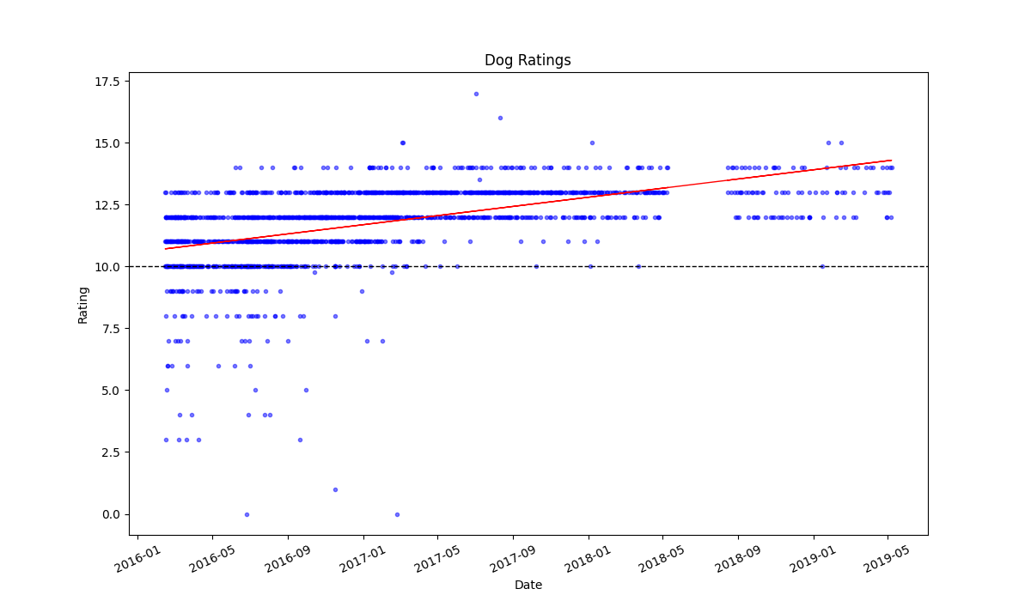

The general trend shows approximately 1700 ratings in the time period. The average was 11.5/10 with min of 0, and max of 17. As time progressed, the ratings plateaued around 13. The inflation period started around April of 2017 as there were no ratings below 10 from then on.

The following graph is a plot of the monthly averages LOESS smooth:

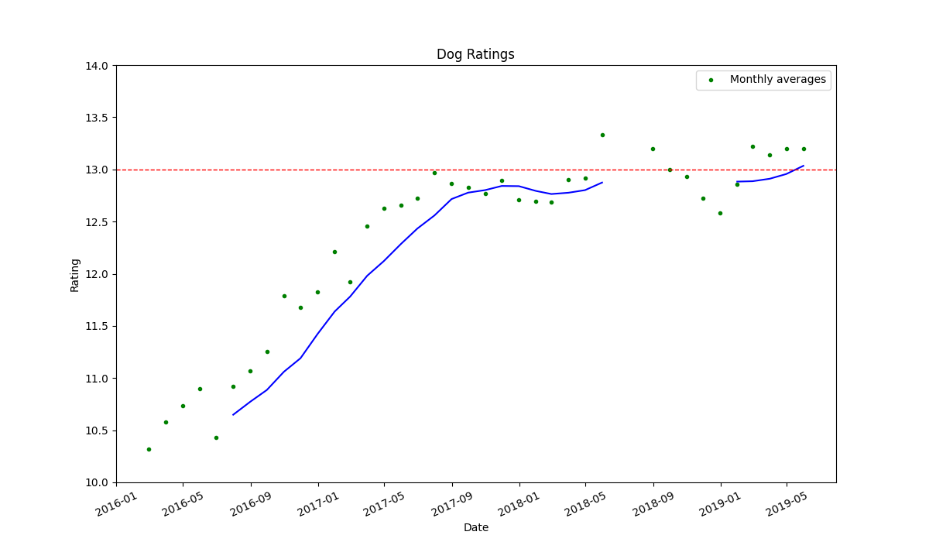

We observe an asymptotic behavior of the time series. The monthly average ratings approach 13 over time and oscillates within ± 0.5 range.

The final graph shows a LOESS smoothing on the monthly averages residuals:

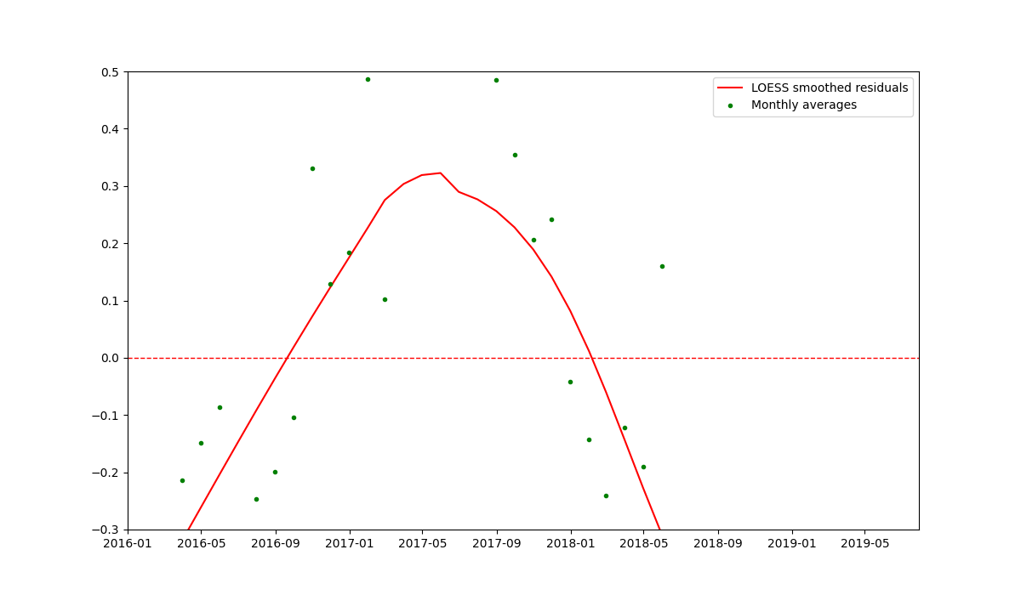

Here, the oscillatory trend was extracted from the fit and one can expect the monthly average ratings to fluctuate between 12.5 and 13.5.